API Test Execution using postman

1. Verify Login API POST 2
a) Execute Login API POST call with Valid required parameters - Fail 2
Observation 1 : While accessing ENSEK Test API Application usign browser, Access-Control-Allow-Origin in the response header captures correct origin while using postman it shows as Asterix *. 2
b) Execute Login API POST call with Invalid required parameters. For e.g. - PASS 3
2. Verify Reset API POST 4
a) Execute Reset API POST call with required Valid Bearer Token - PASS 4
b) Execute Reset API POST call without passing required Valid Bearer Token - PASS 5
3. Verify Buy API PUT 5
a) Execute Buy API PUT call with required Valid parameters - FAIL 5
Observation2: Total cost of the Gas – Energy is displayed up to 15 decimal places in response body which looks incorrect. While for other Energy type it shows up to 2 decimal places. 6
Observation3: Triggering Buy end point would allow user to purchase again the same set of quantity (if not changed) as many time this endpoint is triggered and the remaining quantity goes in negatives. 7
4. Verify Energy API GET 9
a) Execute Energy API GET call with required Valid parameters - Pass 9
5. Verify Bearer Token required for end points 9
a) Execute Get Energy and Reset quantity end point with Bearer Token - FAIL 9
Observation 4: Bearer token is ONLY required for Reset endpoint but Not for ‘Buy’ end point. Breaer token makes more secure if it is made applicable for all other end points 9

Verify Login API POST

Execute Login API POST call with Valid required parameters - Fail
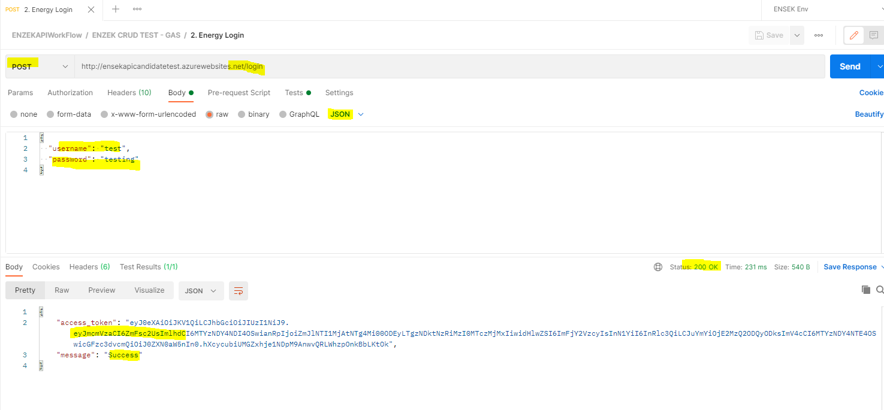

Observation 1 : While accessing ENSEK Test API Application usign browser, Access-Control-Allow-Origin in the response header captures correct origin while using postman it shows as Asterix *.
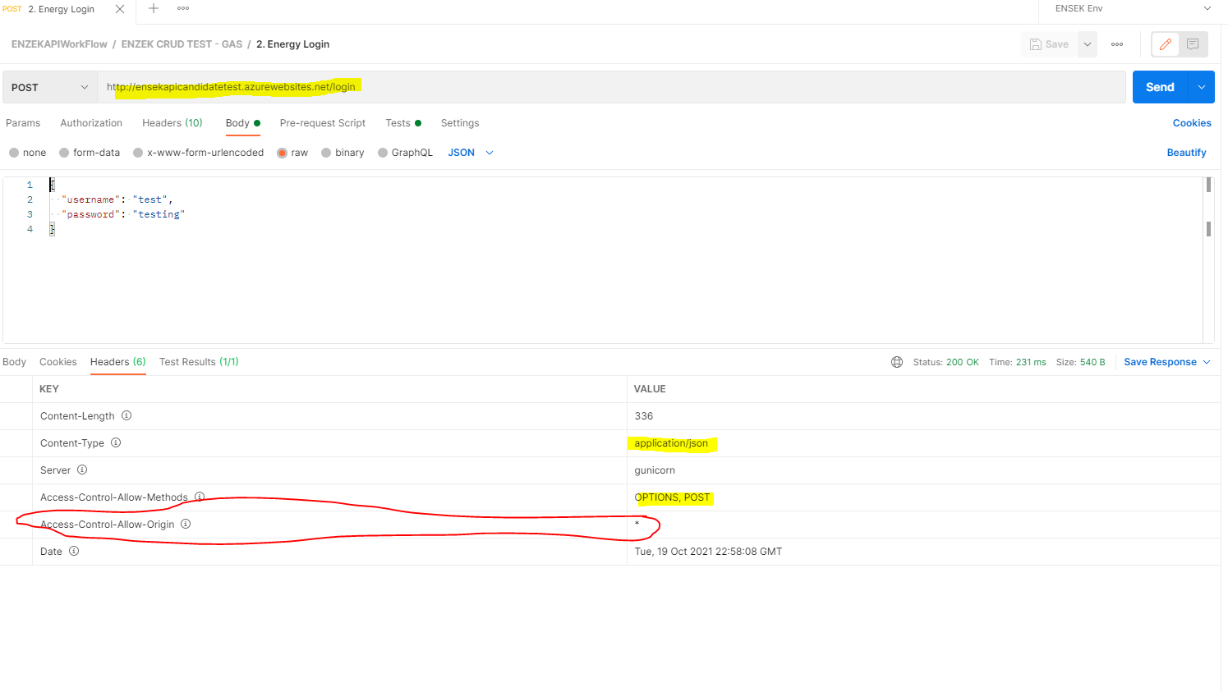

Execute Login API POST call with Invalid required parameters. For e.g. - PASS
'– Missing required parameters
– Invalid value for endpoint parameters

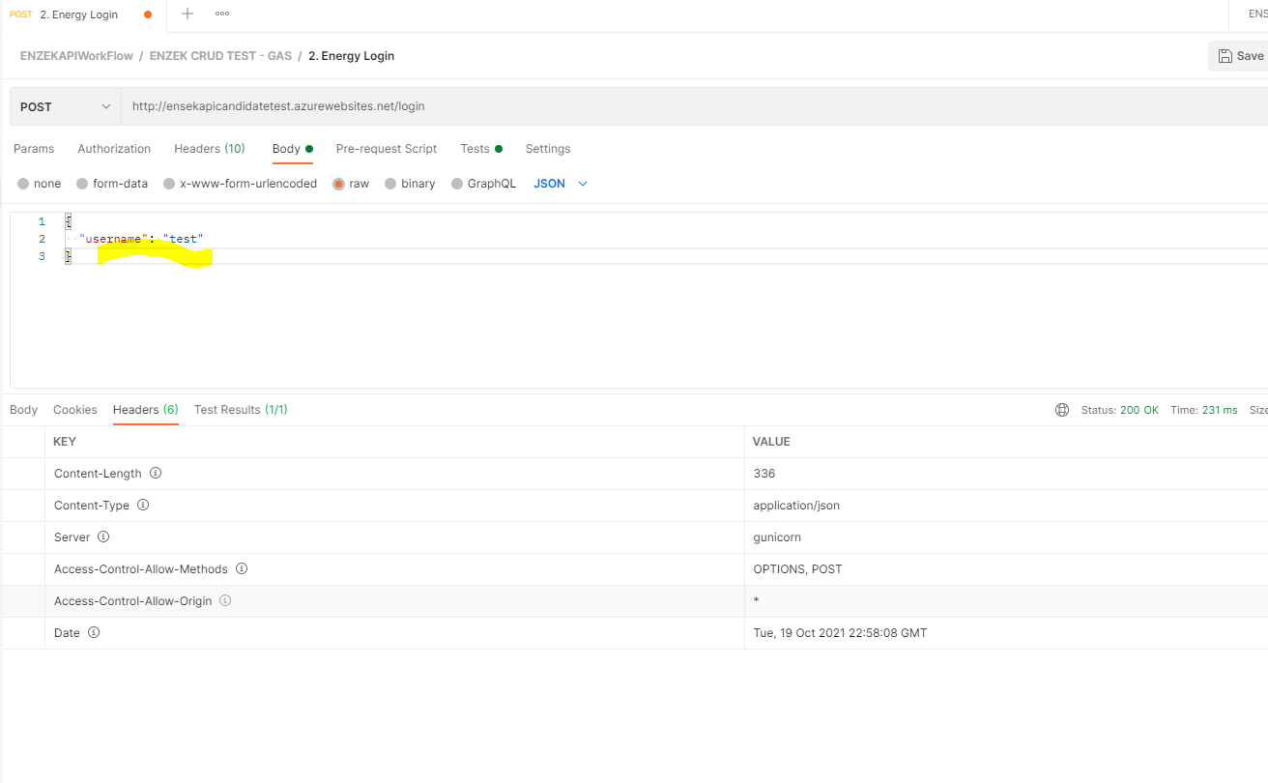

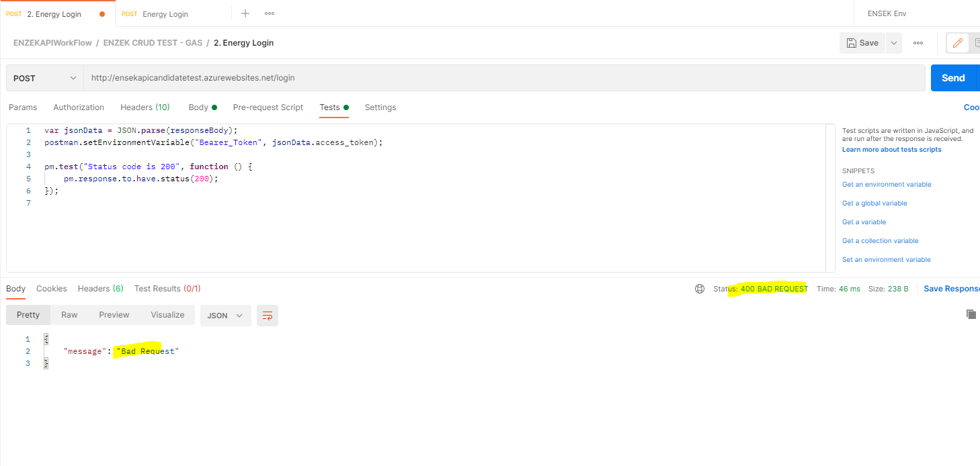

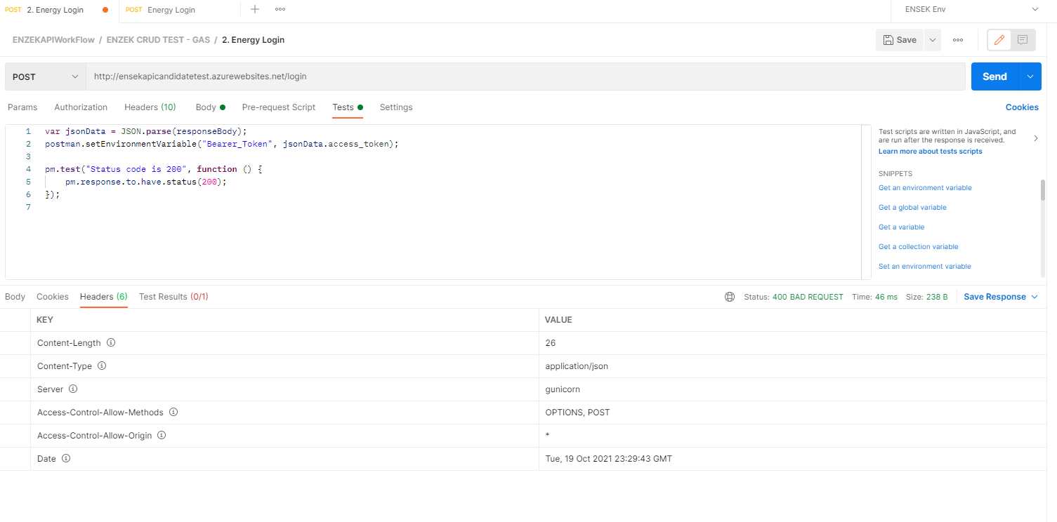

Verify Reset API POST

Execute Reset API POST call with required Valid Bearer Token - PASS
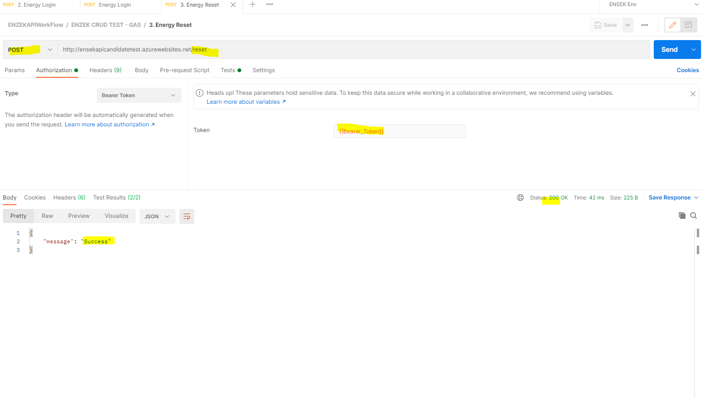

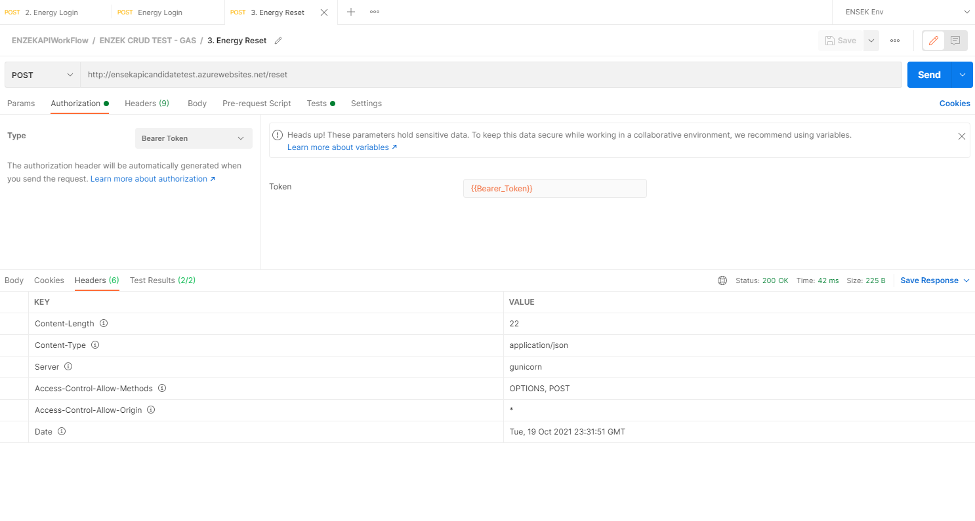

Execute Reset API POST call without passing required Valid Bearer Token - PASS
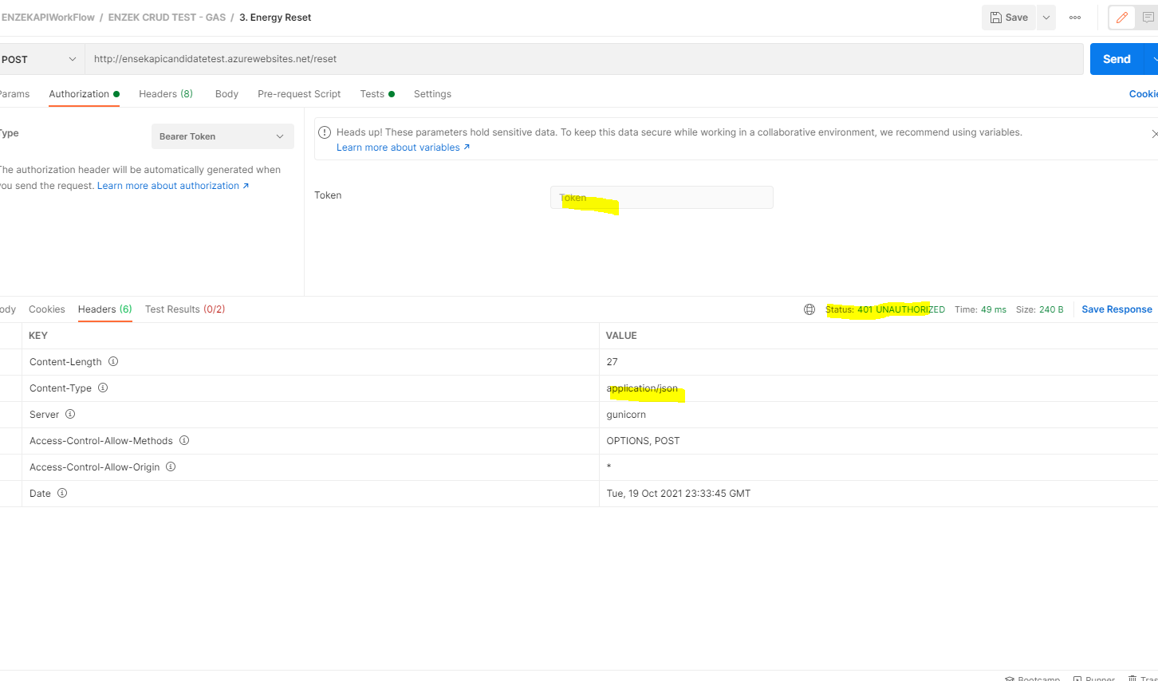

Verify Buy API PUT

Execute Buy API PUT call with required Valid parameters - FAIL

Observation2: Total cost of the Gas – Energy is displayed up to 15 decimal places in response body which looks incorrect. While for other Energy type it shows up to 2 decimal places.
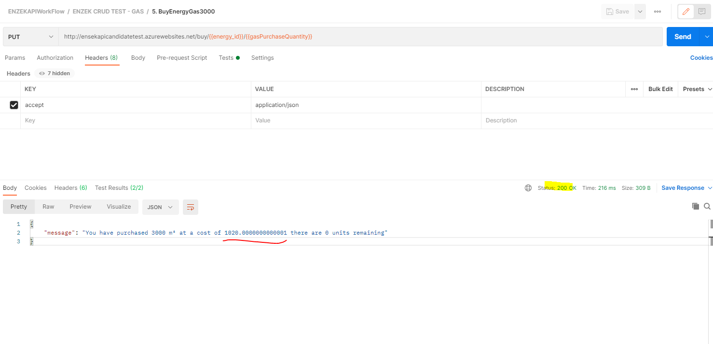

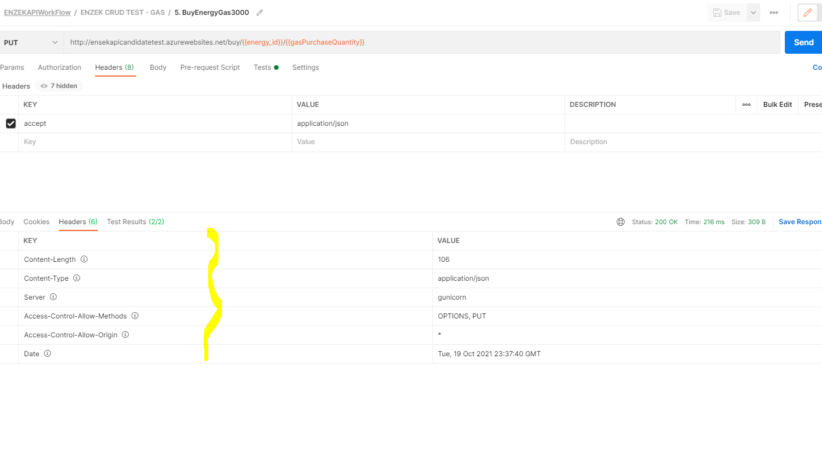
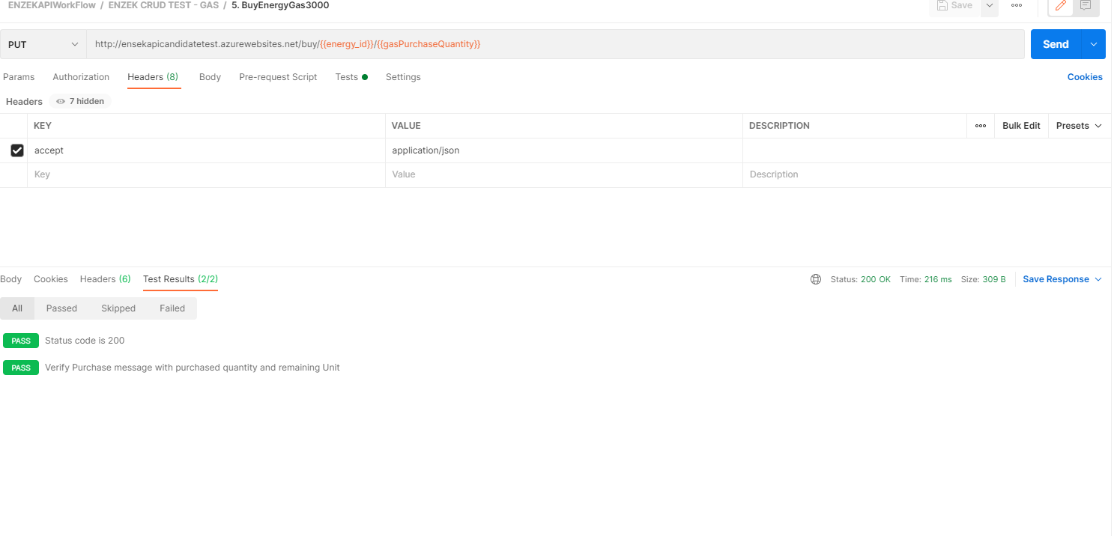

Observation3: Triggering Buy end point would allow user to purchase again the same set of quantity (if not changed) as many time this endpoint is triggered and the remaining quantity goes in negatives.
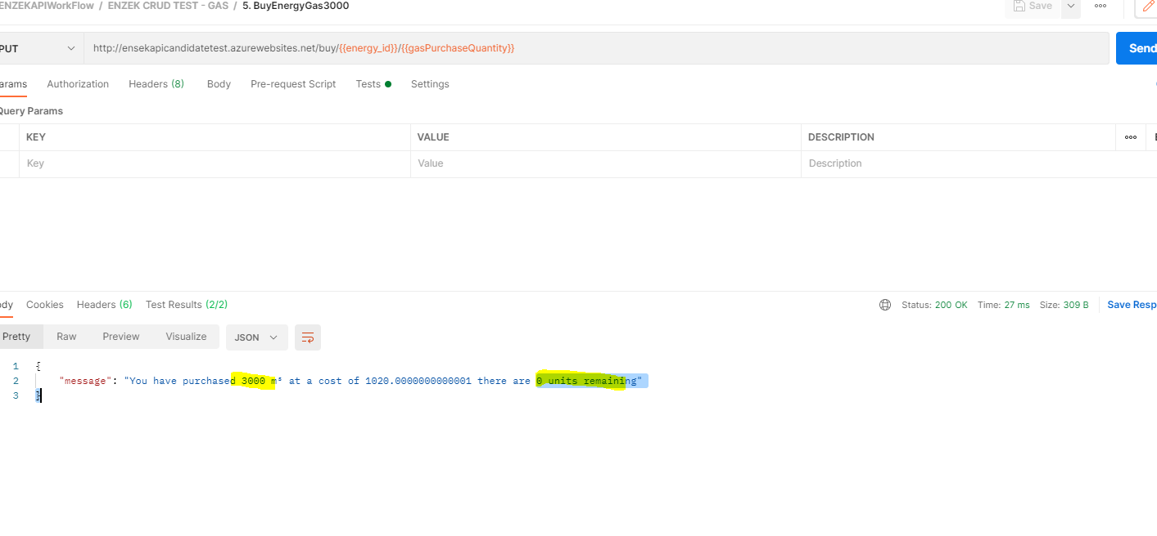
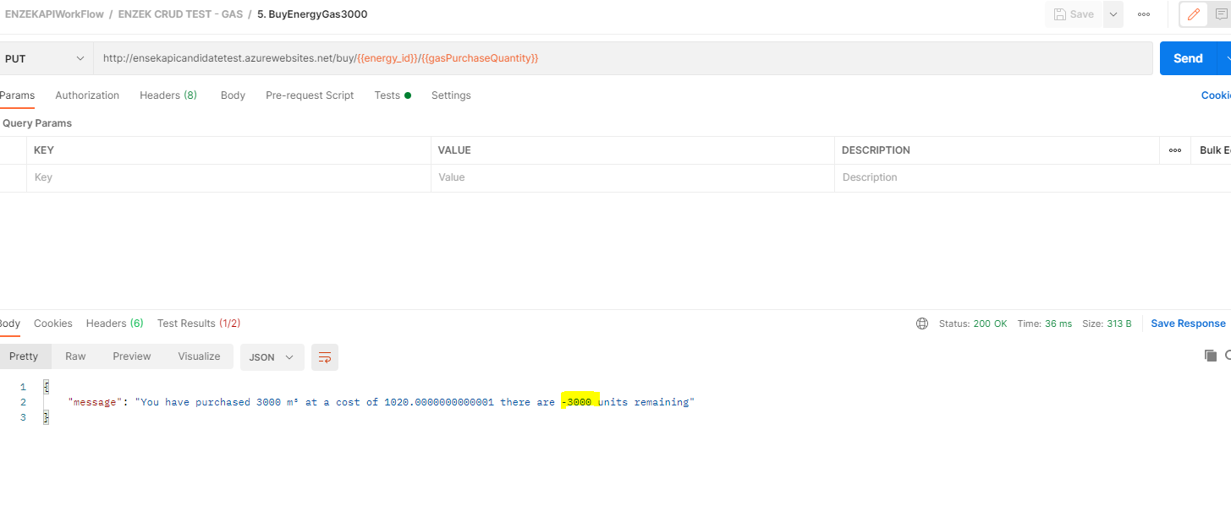
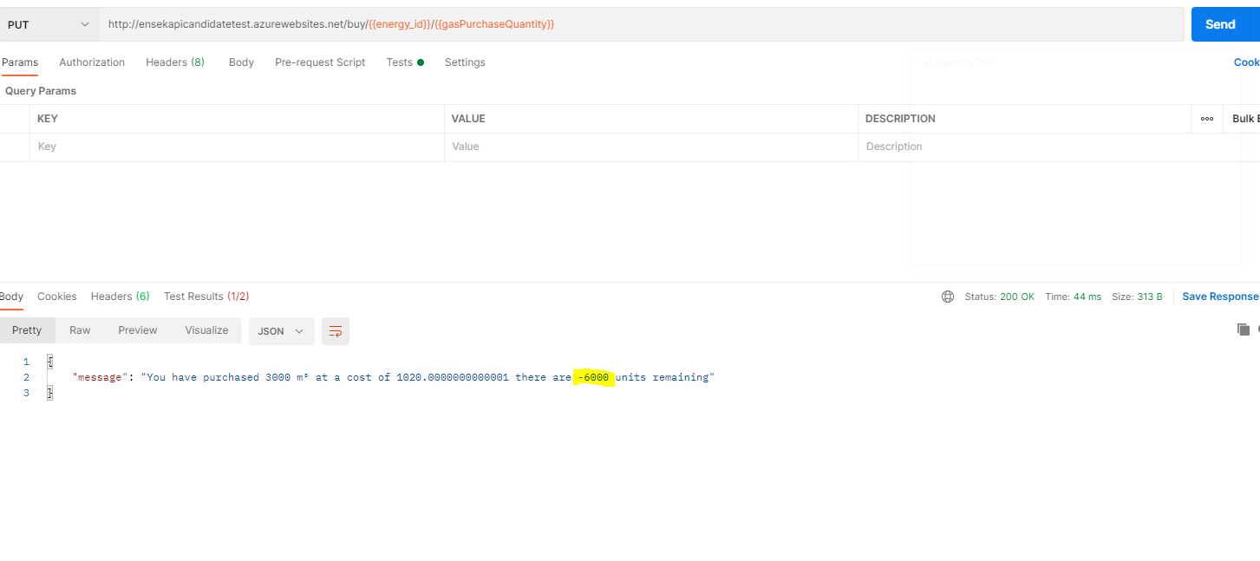

Verify Energy API GET

Execute Energy API GET call with required Valid parameters - Pass
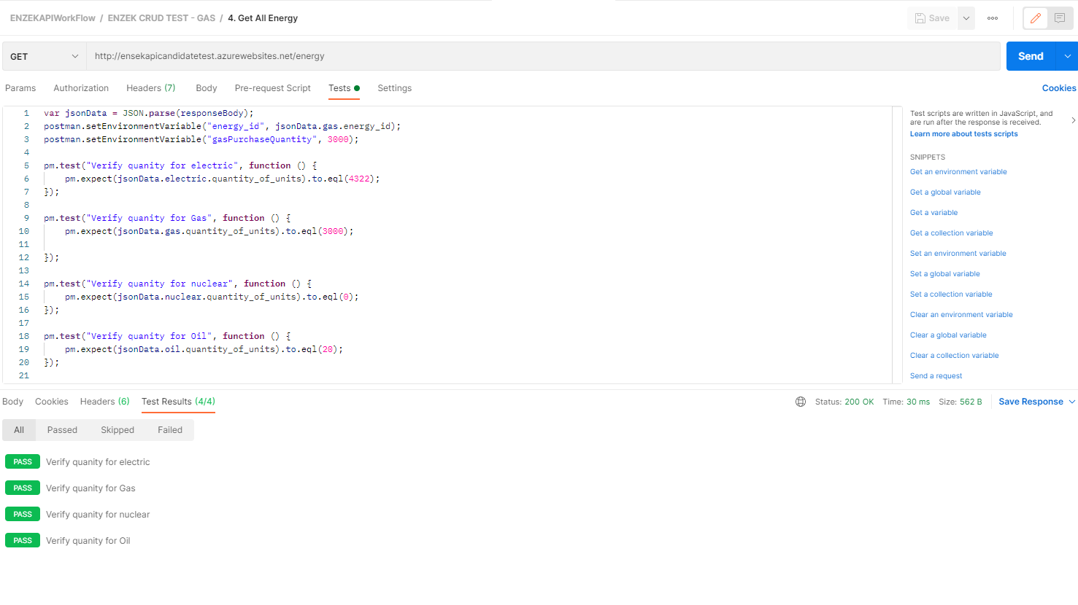

Verify Bearer Token required for end points

Execute Get Energy and Reset quantity end point with Bearer Token - FAIL

Observation 4: Bearer token is ONLY required for Reset endpoint but Not for ‘Buy’ end point. Breaer token makes more secure if it is made applicable for all other end points

Postman Execution – Summary
